Assignment – 3

Name : Abhishek v. Tongale

Reg. No : 2020BIT002

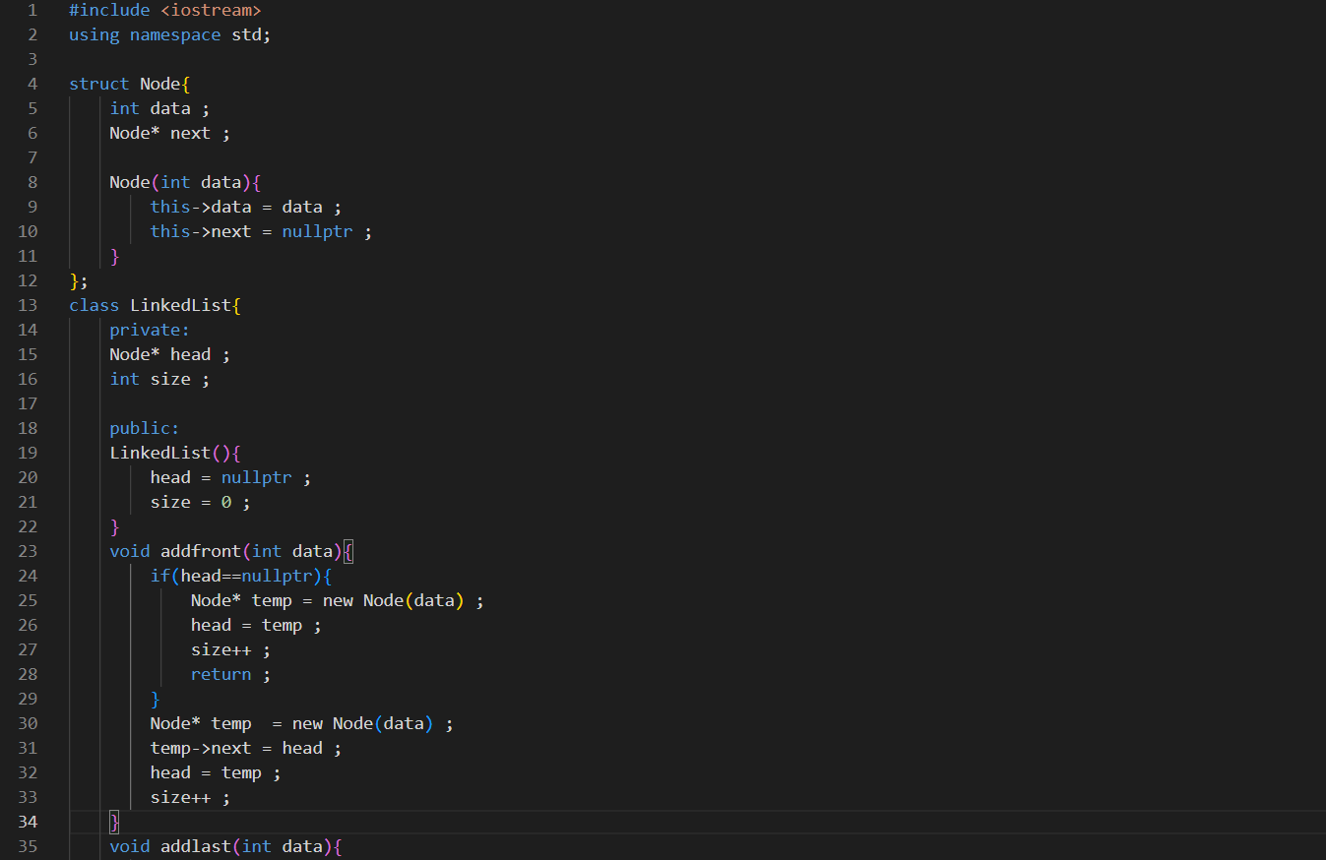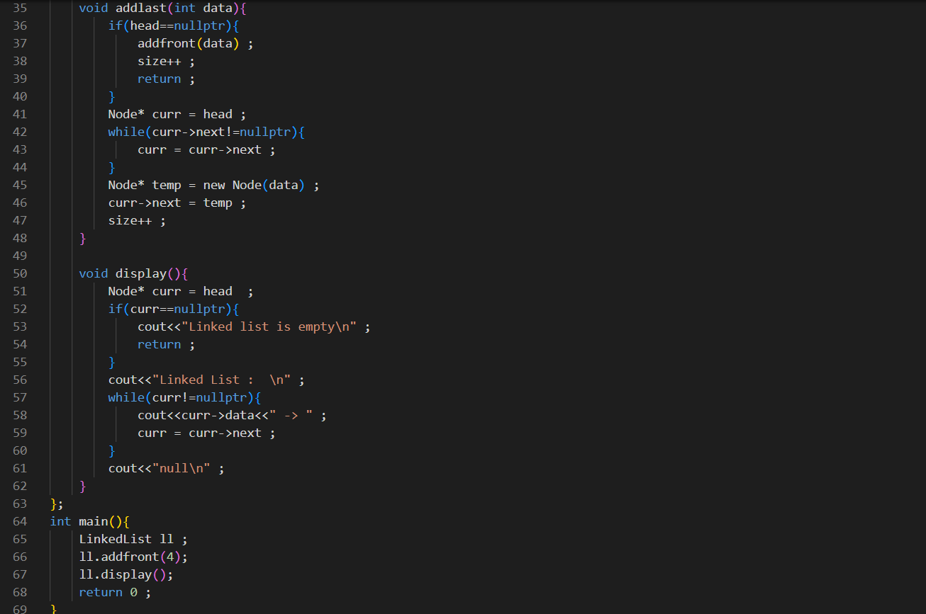

Output:

